Police Related Deaths per 1000 Population in California

Haley Bartosik, Malaika Merid, Vivek Polavarapu, & Mose Wintner

**Memorandum**

DATE: December 2, 2016

TO: Kamala Harris, California Attorney General

FROM: Haley Bartosik, Malaika Merid, Vivek Polavarapu, & Mose Wintner

RE: Police Related Deaths per 1000 Population in California

**I. Executive Summary**

While California boasts the largest population among the United States, it also has the highest number of police related deaths in the country. Though deaths as a result of excessive use of force by police officers have recently become a high profile policy issue in the United States, it is not a new phenomenon. The primary concern of this study is to explore whether structural characteristics of police departments were capable of explaining the rate per unit population of officer-related deaths in California in 2012 by using a least squares model with 18 covariates. Our main variable of interest was a minimum education requirement – we hypothesized that higher education requirements for sworn officers could help mitigate high fatality rates. This study is not the first of its kind; other literature on characteristics that increase the risk of police related deaths and use of force exist in the literature, but examine somewhat different issues, and results range from inconsistent to inconclusive.

**II. Police-Related Deaths in California**

Our model seeks to address whether certain characteristics of police departments have an explanatory effect on the number of police-related deaths of citizens in the state of California. This is an important policy focus today in light of the recent surge of deaths by police which involve civilians that might be people of color, unarmed, and/or suffering from mental health issues. California, among the states, has been very good about tracking deaths at the hands of police and deaths in police custody.

**III. Background**

According to the National Institute of Justice, public perception of police is on a steady decline, especially amongst minorities, due in part to frequent exposure to media reports involving police excessive use of force, misconduct, and abuse of power leading to death (Perceptions of Treatment by Police, 2014). There has been an environment of mutual distrust between police departments and citizens especially amongst minorities in urban areas for decades. In 1985, the Supreme Court decided in Tennessee v. Garner that deadly use of force is to be restricted to situations where a “citizen poses a threat of serious physical harm, either to the officer or to others”, with a consensus that deadly use of force is rarely justifiable (McElvain & Kposowa, 2008). As the 25th anniversary of the Los Angeles riots approaches, we recall that there is evidence that the use of force imparted on Rodney King that spurred the riots is not uncommon.

**IV. Literature Review**

There are several factors thought to influence the likelihood of the use of deadly force by police, many dealing with the organizational components of departments, as well as the role of outside or environmental elements. Certain factors have been examined, most notably an officer’s level of education and the amount of training required (Stickle, 2016). However, impacts of these factors’ effects and explanatory power on use of deadly force remains limited (Ibid.)

It is clear that some organizational components of a department are significant in predicting incidence of deadly force, although the literature disagrees about just how consistent they are. One study found that the organizational size of a department is significant for all departments, but that organizational factors including (but not limited to) the existence of internal affairs unit and training requirements are generally better indicators when looking at city police departments (Eitle et al., 2014). Other research suggests that the hiring process a department utilizes has a larger impact on the number of incidents of use of deadly force. This is thought to be because larger departments require higher levels of education for officers than smaller ones, operate more control over officers, and simply because they have a greater number of employees (Willits and Nowacki, 2013). Further, the same organizational components might not represent both large and small cities effectively because smaller cities might have officers that interact with the same populations and partake in a more community-based style of policing than is present or realistic for a larger department (Ibid.) In contrast, another study found that organizational factors are important determinants for use of deadly force in both small and large city departments, but that organizational structures used in departments policing larger cities may not be appropriate for those in smaller cities. This indicates a need for more qualified officers in smaller cities rather than organizational change, as this seems to play a larger role in the incidents in which deadly force is used in smaller departments (Willits and Nowacki, 2013).

While environmental factors were examined in several previous studies, the only one consistently found to be an influence on use of deadly force was the violent crime rate. The assumption behind this was based on Klinger’s ecological theory, and suggested that if a higher violent crime rate existed, the higher the level of use of force incidents (Eitle et al., 2014). This addresses the idea that with a higher violent crime rate comes a more extensive workload, thus increasing risk of officer-involved fatality. Conversely, it can be argued that this trend is present since the number of encounters with police in general is higher if there is a higher violent crime rate. This study also examined another aspect of Klinger’s theory that addressed the idea of minority group threat, or the idea that as a minority group grows in relative size, the majority group become fearful for safety and protecting their status quo. (Eitle et al., 2014).

As previously mentioned, education level and officer training are some of the most commonly examined factors in a wide range of studies conducted on police departments. A recent study has indicated that officers with a college education are less likely to shoot (Fyfe, 1988 in Stickle, 2016). Further, officers with higher levels of education have been found to communicate better with community members and receive less complaints from citizens, and more required training hours has resulted in less complaints of use of force (Stickle, 2016). Stickle confirms previous analyses suggesting that hiring practices and the quality of officers affects the rate of incidence of deadly force.

While the amount of data regarding factors affecting deadly police force continues to grow, it has its limitations. First, studies disagree on the degree to which organizational factors influence the number of these incidents, as well as which factors are the most significant. There are multiple explanations as to why this might be, including natural variation of data, differing collection methodologies, and subtle differences in survey questions. Therefore, additional research is needed to determine which organizational factors of a department are determinants of deadly force, as well as to determine the significance of environmental factors and their respective levels of impact.

**V. Data Sources**

The data used in the analysis comprised multiple sources. Data about police departments came from the Bureau of Justice Statistics 2013 Law Enforcement Management and Administrative Statistics (LEMAS) survey. Fatality data came from fatalencounters.org (accessed September 30, 2016) which has documented fatalities at the hands of police in the U.S. since 2000. Each data entry is supplemented with a link to online documentation of the incident. This list, compiled and maintained by Cal State Fullerton and Reno News & Review, claims to include complete data on all officer-involved fatalities in California since 2000. The American Community Survey (ACS) provided population demographics. Violent crime data was drawn from the FBI’s Uniform Crime Reporting program (UCR). Finally, arrest rate data came from the California DOJ Office of the Attorney General. Note that whether or not an officer-involved death was deemed “justified” is not included in our analysis.

**VI. Empirical Methodology**

After examining previous literature and running several regressions, the following model was analyzed:

DEATHSPER1000 = β0 + β1 LNCOPS + β2FEM +β3DNONWHITE + β4JNONWHITE + β5NONWHITEINTERACTION + β6IFR + β7TRAIN +β8TRAINREC + β9BUaDG + β10PATR + β11EDU + β12FOOTPOLICY + β13BARG + β14VCPER1000 + β15COPSPER1000 + β16COPSPER10002 + β17LARRESTRATE + β18VCCOPSINTERACTION

***Dependent Variable***

***deathsper1000****: officer-involved deaths per 1000 population in department i from 2000-2015*

We used a rate instead of a count variable because the latter is not typically appropriate for linear regression. Furthermore, using a rate variable helps to control for heteroskedasticity. It is better to use a Poisson regression for a dependent count variable, which results in a far less interpretable model.

***Independent Variables***

***lncopsi****:ln(number of full-time sworn officers in department i)*

This variable is primarily a proxy for the size of the community. We decided to use the number of officers rather than statistics directly related to population because the two are highly correlated and there is more previous work on the effect of the size of a department on officer-related deaths than community population. For example, it has been suggested that in a larger department, an individual officer’s sense of accountability to his or her community and coworkers/superiors is less than for an individual officer in a small department (Willits and Nowacki, 2013). Thus, this variable also attempts to measure individual officers’ senses of accountability.More police in a department does, on average, correlate with more officer-involved deaths and a higher population of the department’s jurisdiction. Therefore, it is unclear what the expected sign of this variable’s regression coefficient should be.

***fem::****proportion of department i that was female in 2012*

It was thought that the gender makeup of a police department might have an associated effect on death rates.This sign was expected to be negative, as it was thought that larger female representation in a department would result in less deaths (Eitle, 2014). A limitation in using this is that instead of a linear correlation between female proportion and death rate, whether or not a department had reached a “critical mass” of female officers (i.e. enough to significantly affect the culture of the department) might have a more significant effect. However, we didn’t attempt to find this boundary.

***dnonwhitei****: proportion of department i that was Hispanic and/or nonwhite in 2012*

The sign was expected to be negative, as it was expected that there would be a lower death rate for departments with greater minority representation (Willits and Nowacki, 2013).

***jnonwhitei****: proportion of jurisdiction of department i that was hispanic and/or nonwhite in 2012*

The sign of the coefficient was expected to be positive, as it was expected that a higher fatality rate would result for jurisdictions with relatively nonwhite and Hispanic populations (Willits and Nowacki, 2013).

***nonwhiteinteractioni****: dnonwhite * jnonwhite*

This interaction term between dnonwhite and jnonwhite gives the model the flexibility to address minority representation *of a community* in its police force. The sign of the coefficient was expected to be negative, because it is the product of the previous two variables.

***ifri****: did the department has incomplete (use of) force records, i.e. the number of incidents of use of force in 2012 by the department was either unknown or an estimate?*

This variable is a proxy for officer sense of accountability. It was expected that the death rate would likely be larger if the police department ended up unsure of the exact number of incidents of force that took place, since this would indicate that a department keeps little to no track of officers with violent streak (i.e. officers who are more likely to commit fatalities.)This sign was expected to be positive, as it was expected that there would a higher death rate if the number of incidents of use of force was unknown or an estimate.

***edui****: does department i require sworn officers to have a high school diploma?*

This was our variable of interest. We wanted to investigate whether or not instating a minimum education requirement has a significant effect on the fatality rate of a police department. Because most departments require sworn officers to hold a high school diploma, this requirement seemed a natural place to begin. This sign was expected to be negative, as it was expected that departments in which every officer must hold a high school diploma, being more reliably educated or reliably intelligent in some sense, would result in a lower death rate.

***traini****: did half or more of the officers in department i complete 8 hours of community policing training in 2012?*

This variable was examined because it was expected to be likely that community policing training could decrease the possibility of an officer finding himself or herself in a life-or-death situation in their community and/or decrease the possibility of officers resorting to lethal force in such situations.This sign was expected to be negative, as it was expected that more training would result in a lower death rate (U.S. Department of Justice, LEMAS).

***trainreci****: did half or more of the new recruits in department i complete 8 hours of community policing training in 2012?*

This variable is different from ***traini*** because departments tend to train new recruits more than existing officers. Indeed, the variables exhibit a low correlation.This sign was expected to be negative, as it was expected that if training was required, there would be fewer deaths (U.S. Department of Justice, LEMAS).

***patri****: were patrol officers in department i regularly assigned to the same areas/beats in 2012?*

An officer on a regularly assigned beat/area might foster relationships with the same community members that would discourage lethal force.This sign was expected to be negative, as it was expected that the closer ties an officer has with an area or community results in a lower death rate. However, it seems likely that this effect would be more pronounced in smaller communities. In future works, this could be translated into an interaction term which would be 0 for communities exceeding a certain size.

***budgi****: operating budget per full-time sworn officer in department i in 2012 (7 missing values)*

It was expected that a higher operating budget per full-time sworn officer would be indicative of aspects of a department’s jurisdiction which might be negatively correlated with fatalities. For example, a higher operating budget per officer could be indicative of a wealthy community, hence with less violent crime on average and fewer violent threats to police. This sign was expected to be negative, i.e. that there would be fewer deaths per population the higher the department’s operating budget per officer was.

***footpolicyi****: does department i have a policy on how to conduct pursuit on foot? (4 missing values)*

Most of the fatalities examined were due to gunshots most likely conducted during pursuit of a suspect on foot. This sign was expected to be negative.

***bargi****: did department i have an active collective bargaining agreement among its sworn officers in 2012?*

This variable was examined because (Willits & Nowacki, 2013) found it significant. The expected sign was thought to be positive, as it was expected that there would be a higher death rate because officers protected by a union would feel less directly accountable to their communities.

***vcper1000i****: violent crimes per 1000 people in jursidiction i in 2012*

As mentioned, previous studies found this to be a significant environmental factor (Eitle et al., 2014). This sign was expected to be positive, as the higher the rate of violent crimes, the more officer-involved fatalities.

***larrestratei****: ln(number of arrests by department i in 2012) / population of jurisdiction of department i in 2012)*

We expected this would be an indicator of certain police-community tensions and interactions not elsewhere measured in the study. This variable measures something distinct ***vcper1000***, whichmeasures violent tendencies of the community and ***larrestrate*** measures police response. This sign was expected to be positive (Harris, 2014).

***copsper1000i****: number of full-time sworn officers per 1000 people in jurisdiction of department i*

***copsper10002i****: previous term squared*

These measure community policing parameters and pressures that an officer might feel from being responsible for a very large or very small portion of the department’s jurisdiction, holding all else constant. For example, an officer in a large community with a small police department may have more responsibilities than an officer in a large community with a large police department. In the former case, for example, a large community with a large police department may need more officers for bureaucratic work. Also, the number of officers per unit population and the number of fatalities per unit population are not likely to scale at the same rates. Therefore, we used a quadratic term to account for any curvature in the relationship between the number of officers per 1000 people and the number of deaths per 1000 people. It was expected that the sign on ***copsper10002*** would be positive, because as the population grows from medium to large, it was expected that the number of deaths would scale up more quickly than the number of officers. Because of this, for very large communities, there would be potentially more police officers but many more deaths. It was expected that the linear term would be negative, as a negative linear term in a quadratic expression with positive quadratic coefficient corresponds to a shift of the vertex of the parabola to the right. This indicates that there is a value of copsper1000 which, on average and holding all else constant, minimizes deathsper1000.

***vccopsinteractioni****: vcper1000i*copsper1000i*

This measures how officers in departments with different violent crime rates but similar police department sizes (and vice versa) respond differently to life-or-death situations.

**VII. Results**

Based on the literature review and data observed, the primary variable of interest selected was a minimum education requirement. The expected sign (negative) was later confirmed through the regression, but the variable was statistically insignificant. The magnitude of the coefficient (-0.0052734) was very small which suggests that had it been statistically significant it would play a small role in the rate of police related deaths per 1000 population in California.

The variables of the model were jointly significant (F=0.0000), and the adjusted R-squared was 0.4207. However, the adjusted R-squared was much less than the R-squared, 0.4974, possibly indicating irrelevant variables.

The decision was made to drop certain variables as well drop outliers that were significantly impacting the interpretation of our model. Initially, the measure of a pay divide between patrol officers and police chiefs was included because the literature review and data observed had indicated that this could have a significant effect on the number of deaths by police. However, the observed data indicated a significant amount of observations missing that caused bias and inaccurate interpretations based on regressions we ran. The Cook’s distance test was performed and found that the Irwindale department was significantly skewing both our data and regression fit, probably because the population of the department’s jurisdiction (~1400) was extremely low compared to the number of officers in the department (24). The outlier caused our adjusted R-squared to be dramatically inflated, at about 0.94.

It was also discovered that our model does a much better job of describing patterns in departments with large jurisdictions. e.g. sheriff’s departments. When restricted to only those departments (population > 100,000) (n=78), the adjusted R-squared improved to 0.64, but a few variables became less significant. When restricted to small police departments (n=63), the adjusted R-squared was very poor, at about 0.184.

In addition to the other tests performed to test the strength of the model, the VIF test was run in order to detect multicollinearity. The mean VIF was 5.62 ranging from a minimum 1.15 to 30.57. This indicates some presence of multicollinearity, particularly between ***copsper1000*** and ***copsper10002***. However, this is because most of the values of ***copsper1000*** are near 1, and therefore don’t significantly change when squared. Hence, the decision was made not to drop these variables from the model.

**VIII. Conclusions and Limitations**

This study is the only of its kind found to be restricted to California, and is also the only study to examine fatality data including potentially “justified” force. In restricting to California, focus was placed on structural aspects of police in a state which tends to be generally progressive in its policy stances. This helps control for sometimes dramatic differences in state histories of policy and police-community interactions.

Previous studies examined structural elements of police departments, measured general police misconduct or use of force, and did not study the *rates* per unit population at which officer-involved deaths occurred. This study examined the officer-involved fatalities per 1000 population to (a) control for heteroskedasticity and (b) to attempt to get a clearer picture of the jurisdiction size-independent effects of the predictors on the dependent variable. It was deemed necessary because we suspected a larger population to correspond to more officer-involved fatalities, as evidenced by the scatterplot presented in Appendix 7.

Another obvious limitation was evidenced by the Ramsey RESET test; the p-value attained was 0.0209, which was sufficient to reject the null hypothesis that our model was correctly specified. In other words, our model most likely misspecified, probably from omitted variable bias.

Also, some of the independent variables included in the regression demonstrated a different sign than expected from initial predictions, and none of the policy-related variables examined were statistically significant. This is consistent with the RESET test performed, which suggested that important variables may have been excluded. However, the entire LEMAS codebook was examined for structural characteristics of police departments that were thought to have bearing on the dependent variable. Thus, a next step in identifying important variables in officer-related deaths in a community could be to look elsewhere for measurements of police culture and structural components of police departments.

Finally, it was determined that the dependent variable, the rate of officer-related fatalities per unit population, was not the most accurate measure available for a number of reasons. For example, considerations were made regarding calculating the rate using number of officers in the department rather than the population of the jurisdiction. Additionally, it was considered whether or not the study should examine logarithms instead of full counts, so as to ameliorate problems coming from including very large counties in the data. The outliers are from the Los Angeles Sheriff’s Department and the LAPD and present some issues, but are still relevant to the regression (refer to Appendix 8).

Most appropriate would likely be a regression on the number of deaths per department, rather than the deaths per unit population per department. However, OLS is not an appropriate model for this dependent variable; for dependent “counting” variables, a Poisson regression is most appropriate. The regression output for a slightly simplified Poisson model, where *t*-scores are displayed is available in Appendix 6. It is important to note that the dependent variables for these two models are different. The Poisson model had a pseudo-R-squared of 0.8393. However, interpretation of the Poisson model is currently unfeasible, but research in this direction seems a worthy next step.

During the data collection process, a wealth of information regarding the demographic information of police departments and crime statistics within California was collected, but the data on police departments are highly subject to self-reporting bias. With that, the variable of interest edui in our regression is not significant, but past literature suggests that the level of education of officers plays a large role in decreasing the instances of use of force in national studies of police departments (McElvain, 2008). It is recommended to use the data collected in this study as a pilot case for the United States as a whole. The methodologies used to gather national data regarding police related violence and deaths has failed to adequately define which characteristics contribute to, or reduce the incidences within police departments (Hickman, 2016). It is proposed that additional funding and resources be allocated to this study so the contributing factors to this policy issue can be better explored.

**IX. References**

Burghart, B. Fatal Encounters: A step toward creating an impartial, comprehensive and searchable national database of people killed during interactions with law enforcement, [www.fatalencounters.org](http://www.fatalencounters.org/); 2014.

Eitle, D., D’Alessio, S. J., & Stolzenberg, L. (2014). The effect of organizational and environmental factors on police misconduct. Police Quarterly, 17(2), 103-126. doi:10.1177/1098611114522042

Federal Bureau of Investigation. (September 2012). *Crime in the United States, 2012.* Retrieved from<https://ucr.fbi.gov/crime-in-the-u.s/2012/crime-in-the-u.s.-2012>

Harris, K.D. California Department of Justice: Criminal Justice Statistics Center. *Crime in California 2014.* Retrieved from<https://oag.ca.gov/sites/all/files/agweb/pdfs/cjsc/publications/candd/cd14/cd14.pdf>

Hickman, M. J., & Poore, J. E. (2015). National Data on Citizen Complaints About Police Use of Force: Data Quality Concerns and the Potential (Mis)Use of Statistical Evidence to Address Police Agency Conduct. *Criminal Justice Policy Review,* *27*(5), 455-479. doi:10.1177/0887403415594843

Lickiss, S. J. (2014). Pre-employment integrity testing with law enforcement and security applicants a closer look at the Law Enforcement Applicant Inventory (LEAI) (Unpublished master's thesis). Alliant International University, California School of Forensic Studies, San Diego.

Mcelvain, J. P., & Kposowa, A. J. (2008). Police Officer Characteristics and the Likelihood of Using Deadly Force. *Criminal Justice and Behavior,* *35*(4), 505-521. doi:10.1177/0093854807313995

Perceptions of Treatment by Police. (n.d.). Retrieved October 31, 2016, from http://nij.gov/topics/law-enforcement/legitimacy/Pages/perceptions.aspx

Stickle, B. (2016, Spring). A National Examination of the Effect of Education, Training and Pre-Employment Screening on Law Enforcement Use of Force. Justice Policy Journal, 13(1), 1-15.

United States Department of Justice. Office of Justice Programs. Bureau of Justice Statistics. Law Enforcement Management and Administrative Statistics (LEMAS), 2013. ICPSR36164-v2. Ann Arbor, MI: Inter-university Consortium for Political and Social Research [distributor], 2015-09-22. http://doi.org/10.3886/ICPSR36164.v2

Willits, D., & Nowacki, J. (2014). Police organisation and deadly force: An examination of variation across large and small cities. Policing & Society, 24(1), 63-80. doi:10.1080/10439463.2013.784314

**Appendix 1**

*Table 1*

*Descriptive Statistics Table*

|  |  |  |  |  |
| --- | --- | --- | --- | --- |
| Variable | Observations | Mean | Standard Deviation | Range |
| deathsper1000 | 145 | 0.0687 | 0.0538 | 0-0.2813 |
| lncops | 145 | 4.831 | 1.2772 | 2.1972-9.2023 |
| fem | 145 | 0.0964 | 0.0467 | 0-0.2727 |
| dnonwhite | 145 | 0.3957 | 0.2509 | 0-1 |
| jnonwhite | 145 | 57.40 | 20.75 | 16.2-99 |
| nonwhiteinteraction | 145 | 3.631 | 9.688 | 0-76 |
| ifr | 145 | 0.5931 | 0.4930 | 0-1 |
| train | 145 | 0.3655 | 0.4832 | 0-1 |
| trainrec | 145 | 0.4759 | 0.5012 | 0-1 |
| budg | 138 | 273272.2 | 88721.59 | 21621.6-788990.8 |
| patr | 145 | 0.7724 | 0.4207 | 0-1 |
| edu | 145 | 0.8483 | 0.3599 | 0-1 |
| footpolicy | 145 | 0.3724 | 0.4851 | 0-1 |
| barg | 145 | 0.8690 | 0.3386 | 0-1 |
| vcper1000 | 144 | 3.535 | 3.043 | .0835-19.87 |
| copsper1000 | 145 | 1.185 | 0.5471 | 0.2591-3.502 |
| copsper10002 | 145 | 1.702 | 1.966 | 0.0671-12.26 |
| vccopsinteraction | 144 | 4.730 | 6.101 | 0.0499-55.71 |
| larrestrate | 145 | -1.363 | 0.8204 | -4.396-0.1847 |

*Table 2*

*Predicted and description signs of variables*

|  |  |  |
| --- | --- | --- |
| *Variable* | *Predicted sign* | *Resulting sign* |
| lncops | *?* | *-* |
| Fem | - | - |
| dnonwhite | - | - |
| Jnonwhite | + | + |
| Nonwhiteinteraction | - | + |
| Ifr | + | + |
| Train | - | - |
| Trainrec | - | - |
| Budg | - | + |
| Patr | - | + |
| Edu | - | - |
| footpolicy | - | - |
| Barg | + | - |
| Vcper1000 | + | + |
| Copsper1000 | - | - |
| Copsper10002 | + | + |
| Vccopsinteraction | + | + |
| larrestrate | + | + |

**Appendix 2: Regression Results**

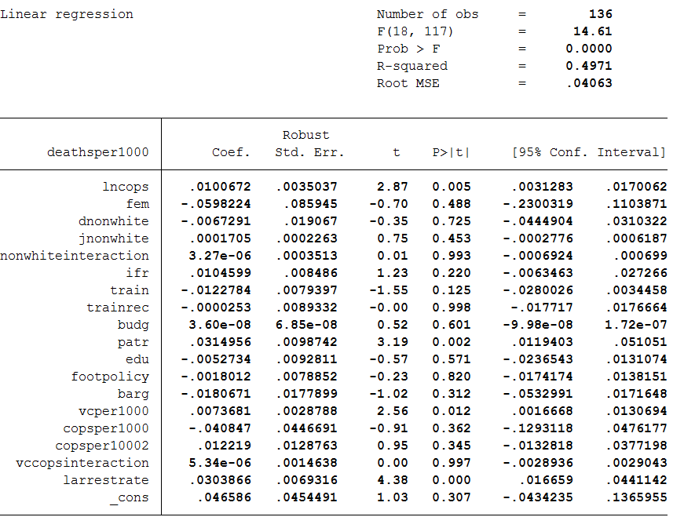

**Appendix 3: Ramsey RESET Results**

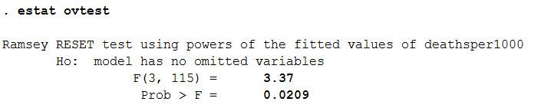

**Appendix 4: big_jurisdiction model includes all departments whose population is >100,000; small_jurisdiction is the rest.**

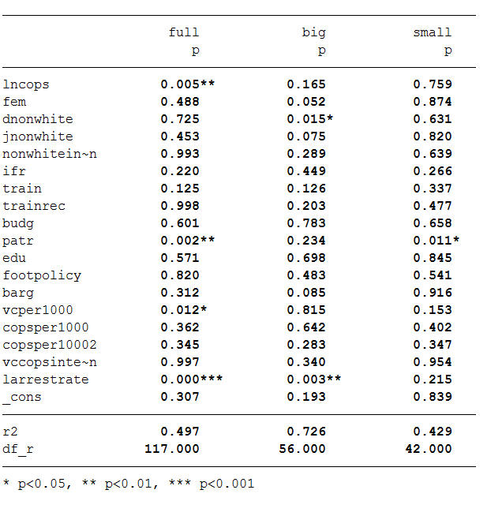

**Appendix 5: Descriptive Statistics**

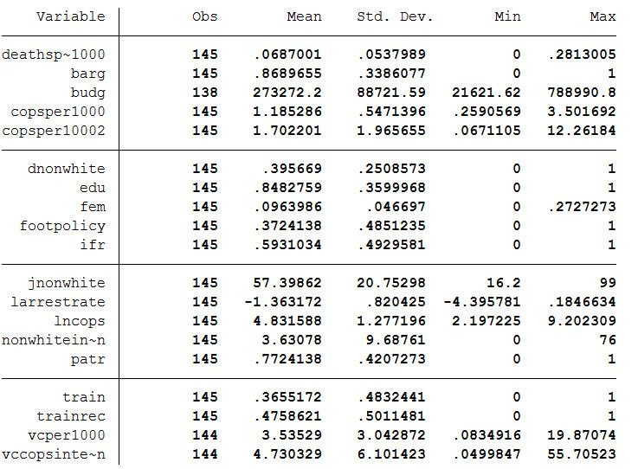

**Appendix 6: Poisson Regression**

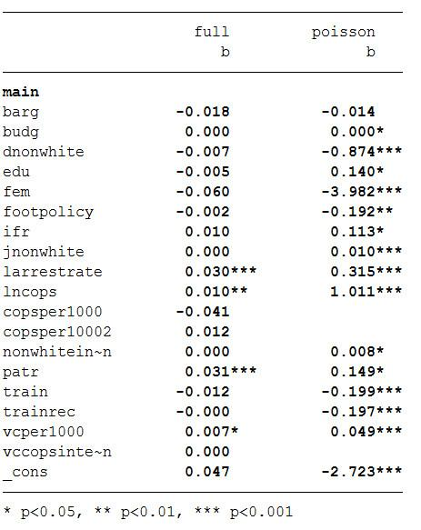

**Appendix 7: Scatterplot**

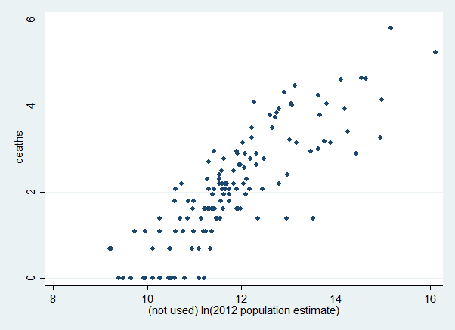

**Appendix 8:**

